Creating Microservices for account and loan:

Account:

Account.java:
package com.cognizant.account.model;
public record Account(String number, String type, double balance) {}

AccountController.java:
package com.cognizant.account.controller;

import org.springframework.web.bind.annotation.GetMapping;
import org.springframework.web.bind.annotation.PathVariable;
import org.springframework.web.bind.annotation.RequestMapping;
import org.springframework.web.bind.annotation.RestController;
import com.cognizant.account.model.Account;

@RestController
@RequestMapping("/accounts")
public class AccountController {

@GetMapping("/{number}")
public Account getAccountDetails(@PathVariable String number) {
// Returning a mock dummy response as specified
return new Account(number, "savings", 234343.0);
}
}

Loan:

application.properties:
spring.application.name=loan
server.port=8081

Loan.java:
package com.cognizant.loan.model;
public record Loan(String number, String type, double loan, double emi, int tenure) {}

LoanController.java:
package com.cognizant.loan.controller;

import org.springframework.web.bind.annotation.GetMapping;
import org.springframework.web.bind.annotation.PathVariable;
import org.springframework.web.bind.annotation.RequestMapping;
import org.springframework.web.bind.annotation.RestController;
import com.cognizant.loan.model.Loan;

@RestController
@RequestMapping("/loans")
public class LoanController {

@GetMapping("/{number}")
public Loan getLoanDetails(@PathVariable String number) {
// Returning a mock dummy response as specified
return new Loan(number, "car", 400000.0, 3258.0, 18);
}
}

Output:

Account: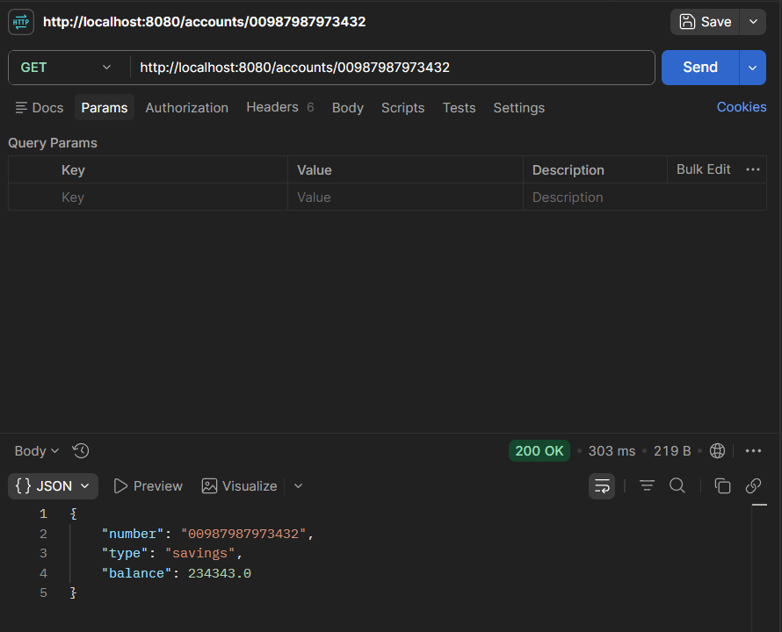

Loan: